**A**

***PROJECT REPORT***

*on*

**MUNCH MATE: RESTAURANT MANAGEMENT WEBSITE**

*Submitted in partial fulfilment of the requirements for the degree of*

**BACHELOR OF TECHNOLOGY**



Session: - 2024

Submitted by

Aashish Patel(20ETCCS001)

Amartya Panwar(20ETCCS007)

Devraj Singh Rao (20ETCCS032)

Dixant Mishra(20ETCCS038)

Mohammed Amaan(20ETCCS072)

Virendra Singh Panwar(20ETCCS115)

Under Guidance of

Mr. Aaditya Maheshwari

Assistant Professor

Computer Science & Engineering

**DEPARTMENT OF COMPUTER SCIENCE AND ENGINEERING**

**TECHNO INDIA NJR INSTITUTE OF TECHNOLOGY, UDAIPUR-313001**

**2024**

**A**

***PROJECT REPORT***

*on*

**Munch Mate: Restaurant Management Website**

*Submitted in partial fulfilment of the requirements for the degree of*

**BACHELOR OF TECHNOLOGY**



**Session: - 2024**

Submitted by

Aashish Patel (20ETCCS001)

Amartya Panwar (20ETCCS007)

Devraj Singh Rao (20ETCCS032)

Dixant Mishra (20ETCCS038) Mohammed Amaan (20ETCCS072) Virendra Singh Panwar (20ETCCS115)

Under Guidance of

Mr. Aaditya Maheshwari

Assistant Professor

Computer Science & Engineering

**DEPARTMENT OF COMPUTER SCIENCE AND ENGINEERING**

**TECHNO INDIA NJR INSTITUTE OF TECHNOLOGY, UDAIPUR-313001**

**2024**



Department of Computer Science and Engineering

Techno India NJR Institute of Technology, Udaipur-313001

**Certificate**

This is to certify that project work titled **“Munch Mate: Restaurant Management Website”** by **Aashish Patel** was successfully carried out in the Department of Computer Science and Engineering, TINJRIT and the report is approved for submission in the partial fulfillment of the requirements for award of degree of Bachelor of Technology in Computer Science and Engineering.

Mr. Aaditya Maheshwari Dr. Rimpy Bishnoi

Assistant Professor Professor and HOD

Computer Science & Engineering Dept. of CSE TINJRIT, Udaipur

Date Date



Department of Computer Science and Engineering

Techno India NJR Institute of Technology, Udaipur-313001

**Certificate**

This is to certify that project work titled **“Munch Mate: Restaurant Management Website”** by **Amartya Panwar** was successfully carried out in the Department of Computer Science and Engineering, TINJRIT and the report is approved for submission in the partial fulfillment of the requirements for award of degree of Bachelor of Technology in Computer Science and Engineering.

Mr. Aaditya Maheshwari Dr. Rimpy Bishnoi

Assistant Professor Professor and HOD

Computer Science & Engineering Dept. of CSE TINJRIT, Udaipur

Date Date



Department of Computer Science and Engineering

Techno India NJR Institute of Technology, Udaipur-313001

**Certificate**

This is to certify that project work titled **“Munch Mate: Restaurant Management Website”** by **Devraj Singh Rao** was successfully carried out in the Department of Computer Science and Engineering, TINJRIT and the report is approved for submission in the partial fulfillment of the requirements for award of degree of Bachelor of Technology in Computer Science and Engineering.

Mr. Aaditya Maheshwari Dr. Rimpy Bishnoi

Assistant Professor Professor and HOD

Computer Science & Engineering Dept. of CSE TINJRIT, Udaipur

Date Date



Department of Computer Science and Engineering

Techno India NJR Institute of Technology, Udaipur-313001

**Certificate**

This is to certify that project work titled **“Munch Mate: Restaurant Management Website”** by **Dixant Mishra** was successfully carried out in the Department of Computer Science and Engineering, TINJRIT and the report is approved for submission in the partial fulfillment of the requirements for award of degree of Bachelor of Technology in Computer Science and Engineering.

Mr. Aaditya Maheshwari Dr. Rimpy Bishnoi

Assistant Professor Professor and HOD

Computer Science & Engineering Dept. of CSE TINJRIT, Udaipur

Date Date



Department of Computer Science and Engineering

Techno India NJR Institute of Technology, Udaipur-313001

**Certificate**

This is to certify that project work titled **“Munch Mate: Restaurant Management Website”** by **Mohammed Amaan** was successfully carried out in the Department of Computer Science and Engineering, TINJRIT and the report is approved for submission in the partial fulfillment of the requirements for award of degree of Bachelor of Technology in Computer Science and Engineering.

Mr. Aaditya Maheshwari Dr. Rimpy Bishnoi

Assistant Professor Professor and HOD

Computer Science & Engineering Dept. of CSE TINJRIT, Udaipur

Date Date



Department of Computer Science and Engineering

Techno India NJR Institute of Technology, Udaipur-313001

**Certificate**

This is to certify that project work titled **“Munch Mate: Restaurant Management Website”** by **Virendra Singh Panwar** was successfully carried out in the Department of Computer Science and Engineering, TINJRIT and the report is approved for submission in the partial fulfillment of the requirements for award of degree of Bachelor of Technology in Computer Science and Engineering.

Mr. Aaditya Maheshwari Dr. Rimpy Bishnoi

Assistant Professor Professor and HOD

Computer Science & Engineering Dept. of CSE TINJRIT, Udaipur

Date Date



Department of Computer Science and Engineering

Techno India NJR Institute of Technology, Udaipur-313001

**Examiner Certificate**

This is to certify that the following student **Aashish Patel** of final year B.Tech. (Computer Science and Engineering), was examined for the project work titled ***“*Munch Mate: Restaurant Management Website*”*** during the academic year 2023 – 2024 at Techno India NJR Institute of Technology, Udaipur

**Remarks:**

**Date:**

Signature Signature

(**Internal Examiner**) (**External Examiner**)

Name: - Name: -

Designation: - Designation: -

Department: - Department: -

Organization: - Organization: -



Department of Computer Science and Engineering

Techno India NJR Institute of Technology, Udaipur-313001

**Examiner Certificate**

This is to certify that the following student **Amartya Panwar** of final year B.Tech. (Computer Science and Engineering), was examined for the project work titled ***“*Munch Mate: Restaurant Management Website*”*** during the academic year 2023 – 2024 at Techno India NJR Institute of Technology, Udaipur

**Remarks:**

**Date:**

Signature Signature

(**Internal Examiner**) (**External Examiner**)

Name: - Name: -

Designation: - Designation: -

Department: - Department: -

Organization: - Organization: -



Department of Computer Science and Engineering

Techno India NJR Institute of Technology, Udaipur-313001

**Examiner Certificate**

This is to certify that the following student **Devraj Singh Rao** of final year B.Tech. (Computer Science and Engineering), was examined for the project work titled ***“*Munch Mate: Restaurant Management Website*”*** during the academic year 2023 – 2024 at Techno India NJR Institute of Technology, Udaipur

**Remarks:**

**Date:**

Signature Signature

(**Internal Examiner**) (**External Examiner**)

Name: - Name: -

Designation: - Designation: -

Department: - Department: -

Organization: - Organization: -



Department of Computer Science and Engineering

Techno India NJR Institute of Technology, Udaipur-313001

**Examiner Certificate**

This is to certify that the following student **Dixant Mishra** of final year B.Tech. (Computer Science and Engineering), was examined for the project work titled ***“*Munch Mate: Restaurant Management Website*”*** during the academic year 2023 – 2024 at Techno India NJR Institute of Technology, Udaipur.

**Remarks:**

**Date:**

Signature Signature

(**Internal Examiner**) (**External Examiner**)

Name: - Name: -

Designation: - Designation: -

Department: - Department: -

Organization: - Organization: -



Department of Computer Science and Engineering

Techno India NJR Institute of Technology, Udaipur-313001

**Examiner Certificate**

This is to certify that the following student **Mohammed Amaan** of final year B.Tech. (Computer Science and Engineering), was examined for the project work titled ***“*Munch Mate: Restaurant Management Website*”*** during the academic year 2023 – 2024 at Techno India NJR Institute of Technology, Udaipur.

**Remarks:**

**Date:**

Signature Signature

(**Internal Examiner**) (**External Examiner**)

Name: - Name: -

Designation: - Designation: -

Department: - Department: -

Organization: - Organization: -



Department of Computer Science and Engineering

Techno India NJR Institute of Technology, Udaipur-313001

**Examiner Certificate**

This is to certify that the following student **Virendra Singh Panwar** of final year B.Tech. (Computer Science and Engineering), was examined for the project work titled ***“*Munch Mate: Restaurant Management Website*”*** during the academic year 2023 – 2024 at Techno India NJR Institute of Technology, Udaipur

**Remarks:**

**Date:**

Signature Signature

(**Internal Examiner**) (**External Examiner**)

Name: - Name: -

Designation: - Designation: -

Department: - Department: -

Organization: - Organization: -

**ACKNOWLEDGMENT**

We take this opportunity to record our sincere thanks to all who helped us to successfully complete this work. Firstly, we are grateful to our **supervisor Mr. Aaditya Maheshwari** for his invaluable guidance and constant encouragement, support and most importantly for giving us the opportunity to carry out this work.

We would like to express our deepest sense of gratitude and humble regards to our **Head of Department Dr. Rimpy Bishnoi** for giving invariable encouragement in our endeavors and providing necessary facility for the same. Also a sincere thanks to all faculty members of CSE, TINJRIT for their help in the project directly or indirectly.

Finally, we would like to thank my friends for their support and discussions that have proved very valuable for us. We are indebted to our parents for providing constant support, love and encouragement. We thank them for the sacrifices they made so that we could grow up in a learning environment. They have always stood by us in everything we have done, providing constant support, encouragement and love

**Aashish Patel (20ETCCS001)**

**Amartya Panwar (20ETCCS007)**

**Devraj Singh Rao (20ETCCS032)**

**Dixant Mishra (20ETCCS038)**

**Mohammed Amaan (20ETCCS072)**

**Virendra Singh Panwar (20ETCCS115)**

DEPARTMENT OF COMPUTER SCIENCE AND ENGINEERING

TECHNO INDIA NJR INSTITUTE OF TECHNOLOGY, UDAIPUR-313001

**CONTENTS**

|  |  |
| --- | --- |
| **Name of Contents** | **Page no.** |
| Certificate 1 | 3-8 |
| Certificate 2 | 9-14 |
| Acknowledgements | 15 |
| Contents | 16 |
| List of Figures | 17 |
| Chapter 1: Introduction   * 1. Title of Project   2. Objective of the Project   3. Technology Used   4. Technology Advantages and Disadvantages | 18  18  19  20  21 |
| Chapter 2: Implementation  2.1 Step 1: Registration & Login  2.2 Step 2: Home  2.3 Step 3: Add to Cart & Order   * 1. Step 4: Admin Panel | 22  22  24  25  28 |
| Conclusion | 35 |
| Future Scope | 36 |
| Bibliography | 38 |

**LIST OF FIGURES**

|  |  |
| --- | --- |
| Fig.1 Login Page | 23 |
| Fig.2 Landing Page | 23 |
| Fig.3 Home Page | 24 |
| Fig.4 Cart Summary Page | 25 |
| Fig.5 Location | 26 |
| Fig.6 Orders List Page | 26 |
| Fig.7 Add Item Page | 28 |
| Fig.8 Order Information Page | 32 |
| Fig.9 Order Report Page | 32 |
| Fig.10 Item Master Page | 33 |
| Fig.11 Admin Login Page | 34 |
| Fig.12 Admin Profile Page | 34 |

**CHAPTER 1: INTRODUCTION**

**Name of the project:**

Munch Mate: Restaurant Mangement Website

**Problem Statement:**

As online food ordering platforms have surged in popularity, users continue to face significant challenges that detract from their overall experience. Key issues include a lack of personalized recommendations, inefficient search functionalities, and a dearth of real-time order updates. These shortcomings lead to frustration and decreased user satisfaction. Meanwhile, restaurant partners grapple with difficulties in managing orders effectively and maintaining brand consistency across multiple online channels. Consequently, there is an urgent need to develop a comprehensive food ordering website that addresses these issues. Such a platform must integrate advanced features like personalized recommendations driven by user data, intelligent search algorithms for seamless navigation, real-time order tracking for transparency, and streamlined order management tools for restaurant partners. By designing and implementing a user-friendly and robust food ordering platform, this project aims to revolutionize the online food delivery industry by enhancing the experience for both customers and restaurant partners, ultimately setting a new standard of excellence and efficiency in the digital dining landscape.

**Objective of project:**

***Objective:***

* Develop a User-Friendly Food Ordering Website, Implement Personalized Recommendations, Enhance Search Functionality
* Real-Time Order Tracking
* Efficient Order Management for Admins
* Ensure Security and Reliability

***Scope:***

* User Page Development
* Personalized Recommendations
* Search Functionality
* Real-Time Order Tracking
* Database Integration
* Testing and Quality Assurance
* Documentation and Training
* Future Enhancements

**Technology Stack:**

**React.js:** It forms the core of "Munch Mate" food delivery system's frontend development. It enables modular UI creation with its component-based architecture and efficient rendering via virtual DOM. React's state management capabilities ensure data consistency across components, enhancing user experience. With its robust features and ecosystem, React.js facilitates scalable and responsive web application development, making it an ideal choice for powering dynamic and interactive interfaces like those in "Munch Mate."

**Node.js:** It drives the backend of "Munch mate," offering non-blocking, event-driven architecture for high concurrency. Its extensive npm ecosystem enables rapid development and deployment. Asynchronous I/O ensures efficient handling of client requests, making Node.js ideal for real-time applications like "Munch Mate," ensuring responsive user experiences.

**PostgreSQL:** It serves as the backbone of the "Munch Mate" food delivery system's backend database. Known for its reliability, scalability, and extensibility, PostgreSQL offers advanced features such as ACID compliance, data integrity, and support for complex queries. With its support for JSONB data type and extensions like PostGIS for geospatial data, PostgreSQL enables efficient storage and retrieval of diverse data types, making it a robust choice for managing the system's data.

**VS Code:** Visual Studio Code is utilized as the primary Integrated Development Environment (IDE) for coding and project management in the "Munch Mate" development process. Its extensive ecosystem of extensions, built-in Git integration, and efficient code editing features streamline the development workflow.

**Advantages of Tech Stack:**

**React.js:** Modular UI development, efficient rendering, and robust state management for responsive and scalable frontend.

**PostgreSQL:** Reliability, scalability, and support for complex queries, ensuring efficient data storage and retrieval in the backend database.

**Node.js:** Non-blocking, event-driven architecture, vast ecosystem for rapid development, and asynchronous I/O for efficient handling of client requests, facilitating real-time communication and responsiveness in the backend.

**Disadvantages of Tech Stack:**

**Learning Curve:** Next.js, React.js, PostgreSQL, Node.js

**Complexity:** Integration, Debugging, Maintenance

**Scalability Challenges:** Optimization, Architecture Planning

**Resource Intensiveness:** Hosting Costs, Resource Management

**Community Support:** Limited Resources, Niche Requirements

**CHAPTER 2: IMPLIMENTATION**

**Step 1:** **Registration & Login**

Welcome to Munch Mate, your ultimate food companion for all things delicious! Munch Mate isn't just your average food delivery platform; it's designed to make your culinary experiences delightful and hassle-free.

Embark on your gastronomic journey by registering with Munch Mate. Our registration process is simple yet comprehensive, ensuring we have all the necessary details to enhance your food experience. Provide us with your first name, last name, email address, password, phone number, and age to create your personalized account. Already a member? No worries! Simply click on the login option to access your account seamlessly.

Once you're logged in, get ready to explore a world of flavors at your fingertips. Our intuitive login page requires only your email ID and password to gain access to Munch Mate's treasure trove of culinary delights. But that's not all - we understand the importance of convenience, which is why we offer additional login options through Facebook and Google.

At Munch Mate, we believe that food is not just sustenance; it's an experience to be savored and shared. Whether you're craving comfort food from your favorite local joint or eager to explore exotic cuisines from around the globe, Munch Mate is here to fulfill your every culinary desire.

Join us on this mouthwatering adventure and let Munch Mate be your trusted companion in your culinary escapades. Get ready to tantalize your taste buds and indulge in a world of flavors like never before with Munch Mate - because good food is meant to be enjoyed, and we're here to make it happen!

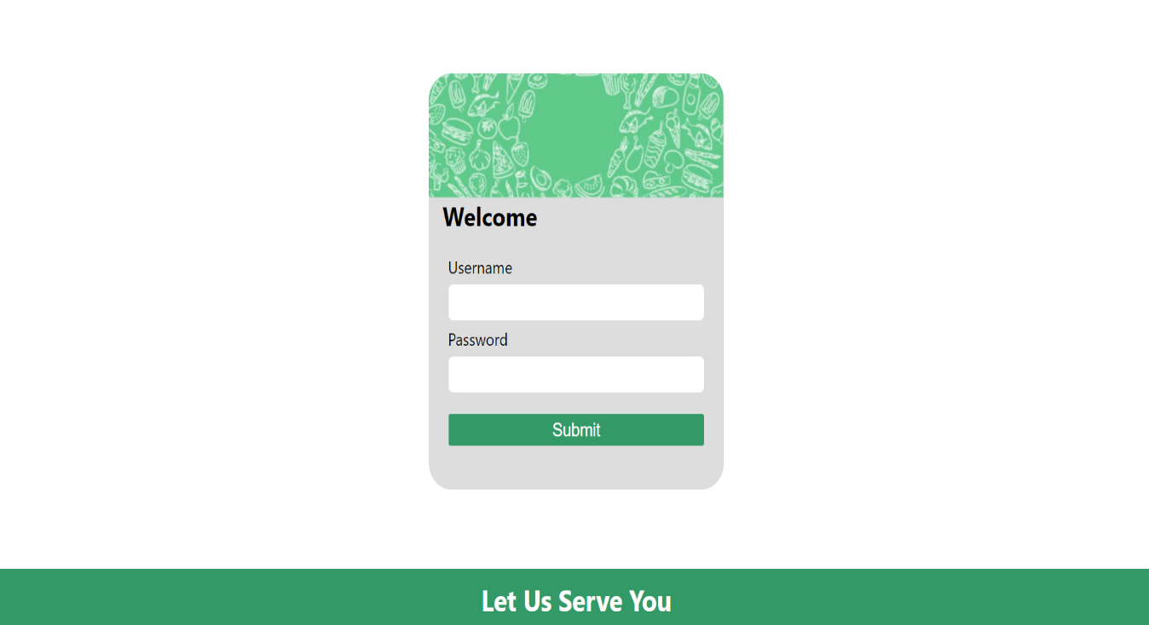

Fig.1 Login Page

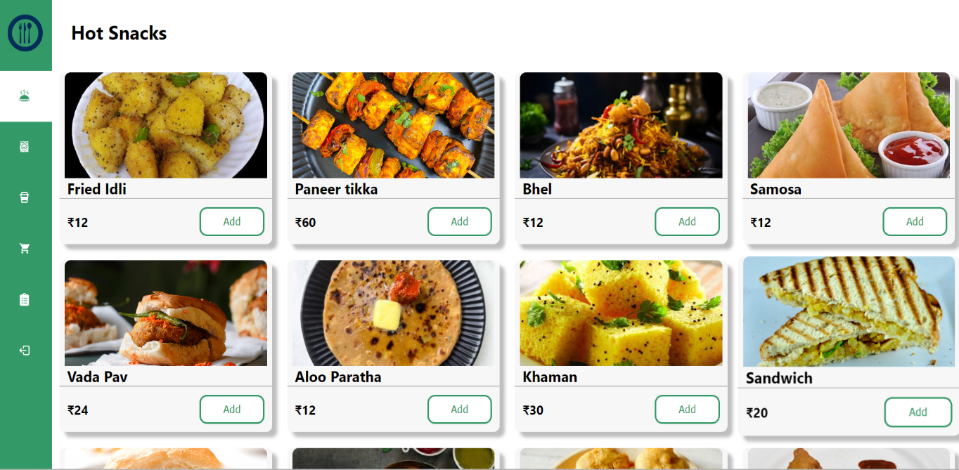

Fig.2 Landing Page

**Step 2: Home**

After logging in to Munch Mate, users are seamlessly redirected to the Home Page, where they encounter a curated selection of Top Rated Items. These items are meticulously chosen based on customer feedback and ratings, offering users a personalized touch that guides them towards exceptional dining experiences. This not only fosters trust and reliability in the platform but also ensures users have access to the best options available. As users navigate through the Home Page, they have the option to explore different Food Categories, catering to diverse culinary preferences.

The Home Page acts as a gateway to a world of culinary delights, providing users with a seamless and personalized dining experience tailored to their diverse tastes and preferences. Here, users have the option to click on the "Add" button to select their desired food quantity and add items to their cart. This intuitive feature enhances convenience and ensures that users can easily customize their orders to suit their cravings and appetite.

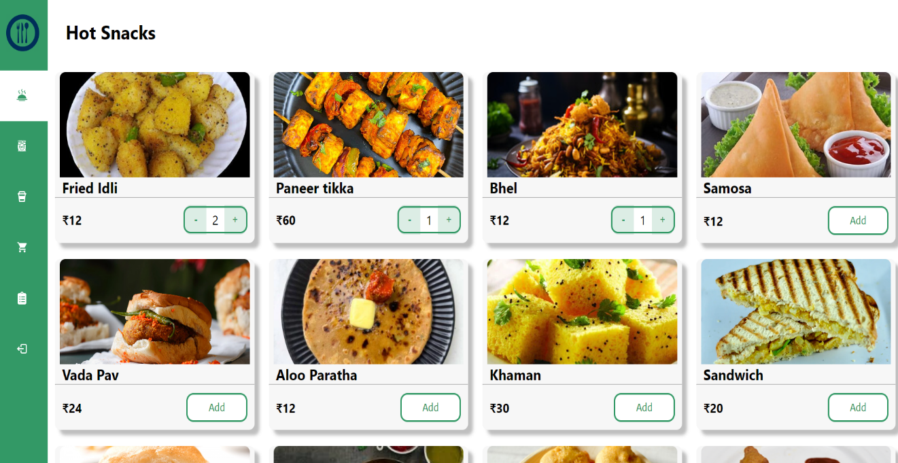

Fig.3 Home Page

**Step 3: Add to Cart & Order**

Once users have clicked on the "Add" button for their desired product, it seamlessly transitions into the cart. Here, users can review their selected items before proceeding to checkout. The cart provides a summary of the order, including:

1. Total Amount: This displays the total cost of all items in the cart, ensuring transparency in pricing.
2. Total Items Count: Users can see the total number of items they've added to their cart, helping them keep track of their order.
3. Required Mobile Number: Users are prompted to provide their mobile number, which is essential for order confirmation and communication regarding the delivery.
4. Delivery Required Within Time: Users can specify their preferred delivery time, allowing for greater flexibility and convenience.
5. Payment Type: Users can choose their preferred payment method, whether it's credit/debit card, cash on delivery, or other available options.
6. Button for Place Order: Once users have reviewed their order details and provided necessary information, they can click on the "Place Order" button to proceed with the checkout process. This initiates the final step to confirm the order and arrange for its delivery.

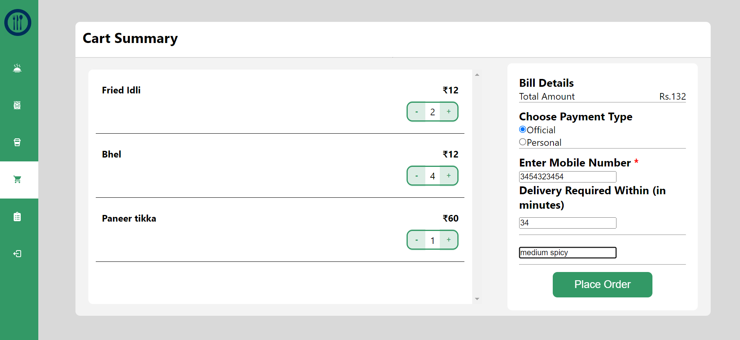

Fig.4 Cart Summary Page

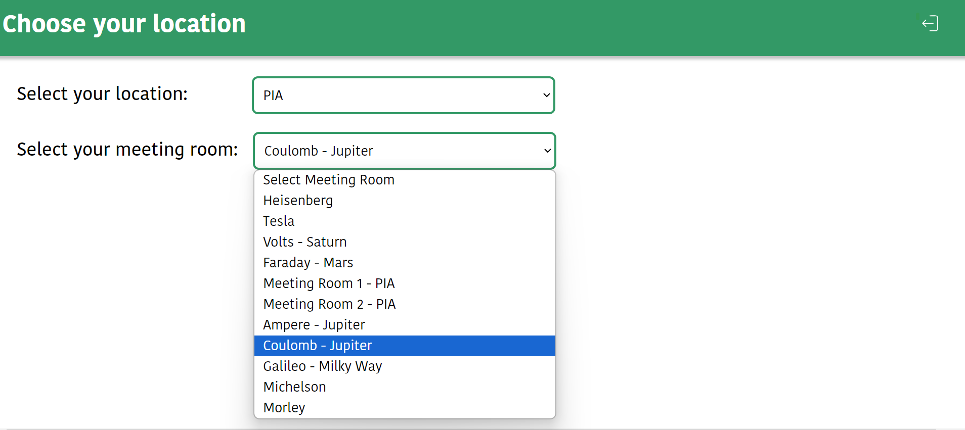

Fig.5 Location

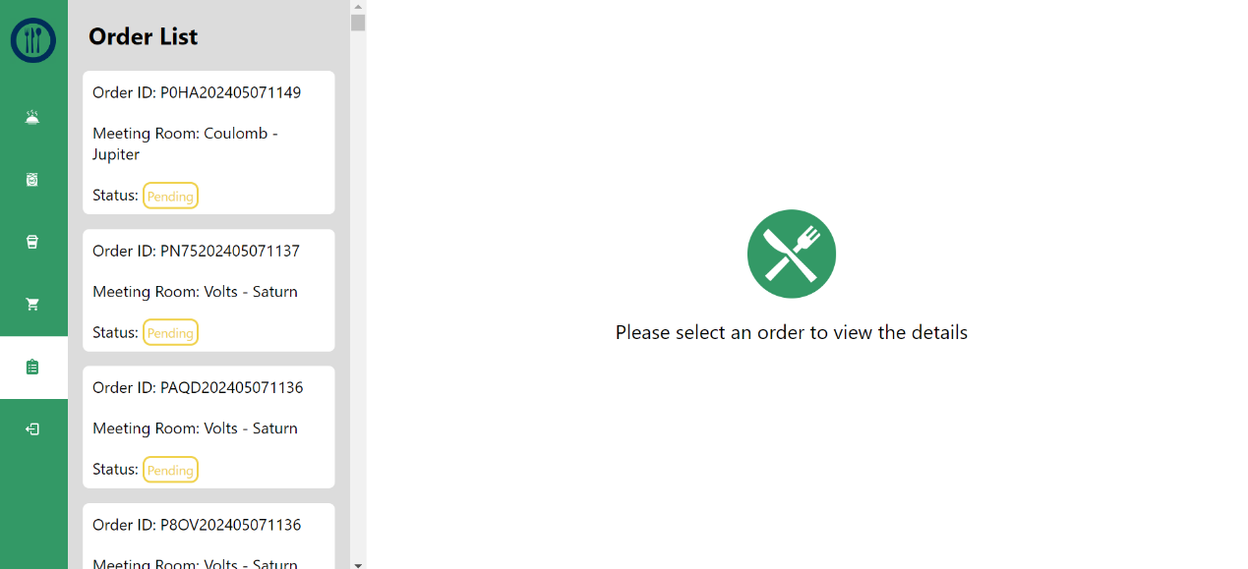

Fig.6 Order List Page

Once the user completes their order, all relevant details are promptly relayed to the admin panel for processing. This includes a comprehensive breakdown of the ordered items and their respective quantities, along with the total cost of the order. User information such as name, email, and mobile number is also transmitted, ensuring smooth communication and accurate delivery. Additionally, the delivery address provided by the user and any specified delivery time preferences are included to facilitate timely shipping. Payment details, including the chosen method, are part of the transmission, allowing for seamless financial transactions. As this information reaches the admin panel, restaurant staff or delivery personnel can efficiently manage the order, updating its status as needed until it is dispatched for delivery. This integration ensures a streamlined process from order placement to fulfillment, benefiting both users and service providers alike.

**Step 4: Admin Panel**

The Admin Panel serves as the central control hub for managing various aspects of the Munch Mate Food Delivery System. With intuitive interfaces and streamlined functionalities, administrators can efficiently oversee restaurant and menu management, monitor orders, and ensure smooth operations.

**Add Items:**

The "Add Items" functionality enables administrators to enrich the platform's menu offerings with enticing dishes and beverages. Administrators can upload captivating item images, specify item names, set item prices, Item ID, provide detailed descriptions, and assign item types and item status. By meticulously curating the platform's menu, administrators enhance user engagement and satisfaction, catering to diverse culinary preferences. Upon inputting item details, administrators can click the "Add item" button to seamlessly incorporate new menu items into the platform's offerings.

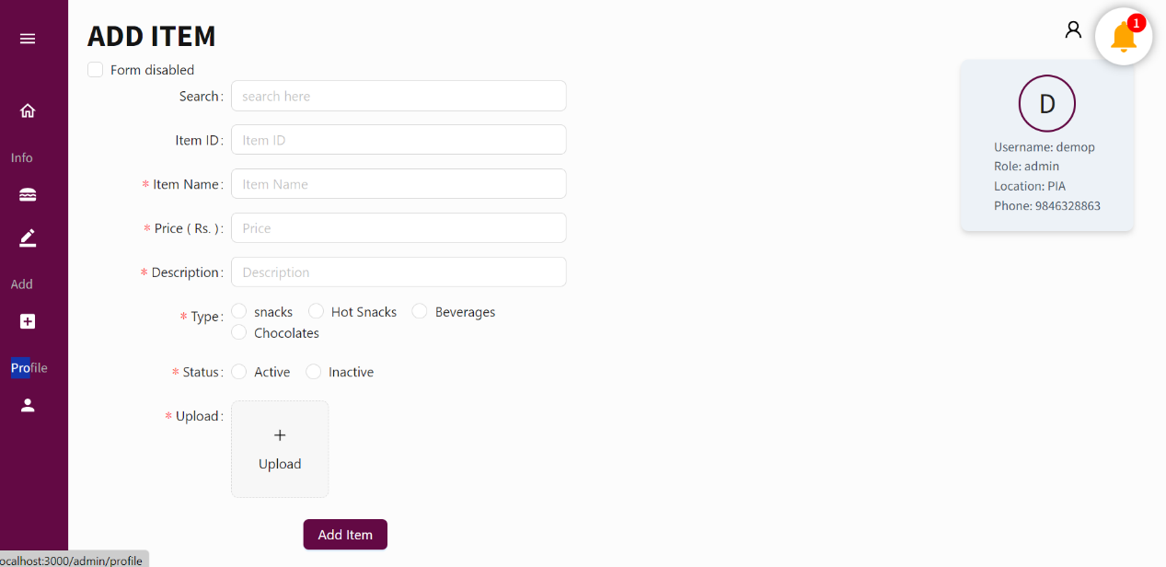

Fig.7 Add item Page

**Admin Dashboard Page:**

The admin panel Dashbord as a centralized hub to manage the various stages of order processing. It displays the details of orders categorized into different statuses: pending, approved, reviewed, and confirmed.

1. **Pending Orders:** These are orders that have been placed by users but have not yet been processed by the restaurant or delivery team. In this section of the admin panel, pending orders are listed along with their respective details, such as order items, user information, and delivery preferences.
2. **Approved Orders:** Once pending orders are reviewed and accepted by the restaurant, they are moved to the approved section of the admin panel. Here, administrators can view the details of approved orders and prepare them for further processing.
3. **Reviewed Orders:** Some orders may require additional scrutiny or verification before approval. These orders are placed in the reviewed category, where administrators can carefully assess their validity and make informed decisions regarding their approval.
4. **Confirmed Orders:** Confirmed orders are those that have been thoroughly reviewed and approved by the admin panel. In this section, administrators can find a finalized list of orders ready for fulfillment and delivery. They can track the progress of confirmed orders and ensure timely dispatch to customers.

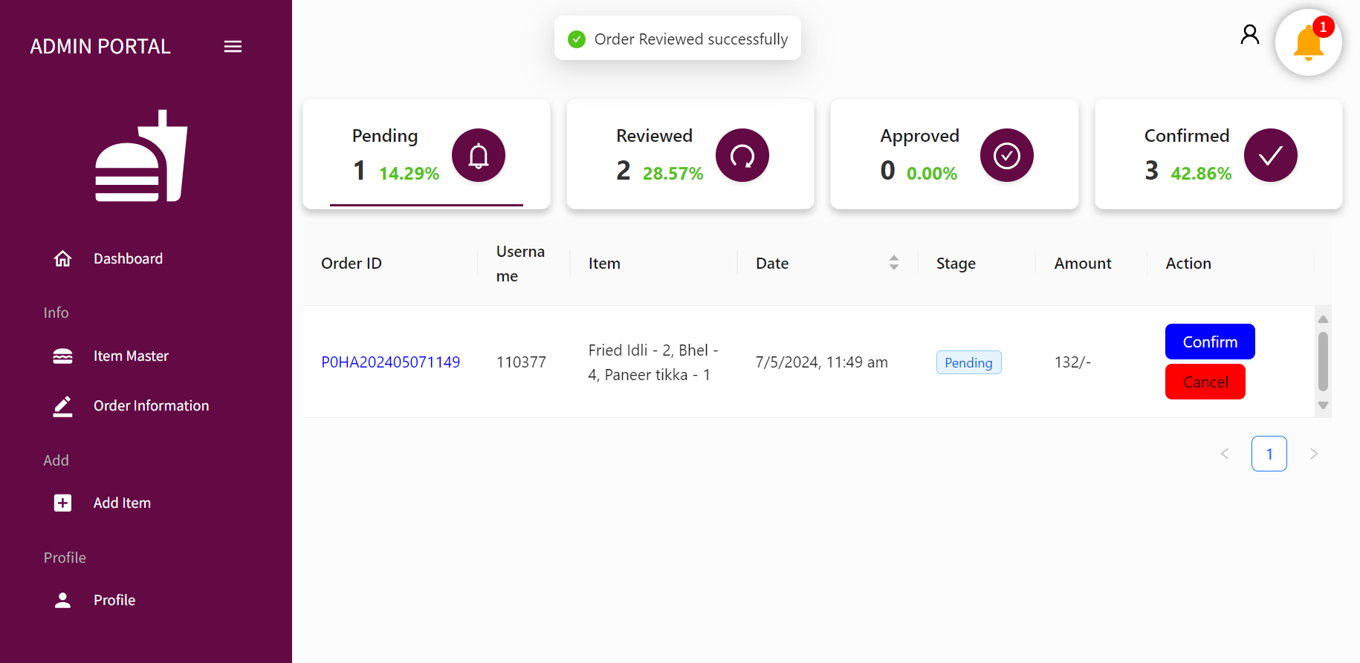

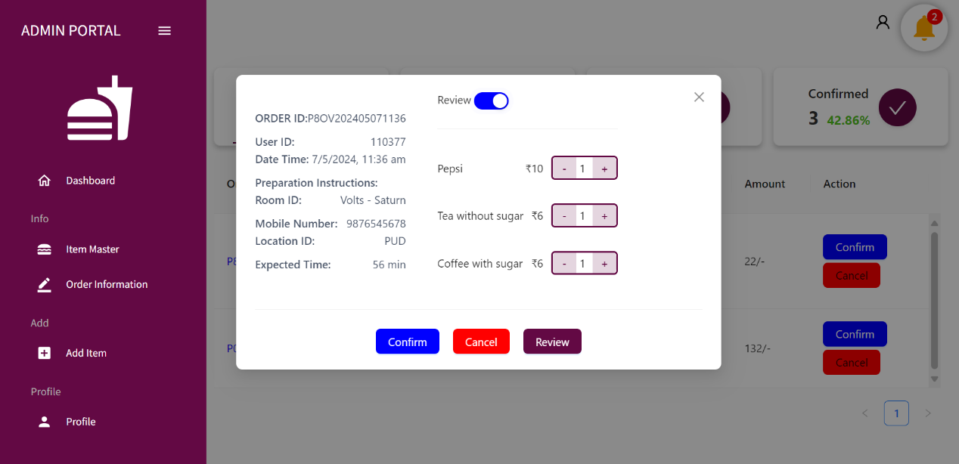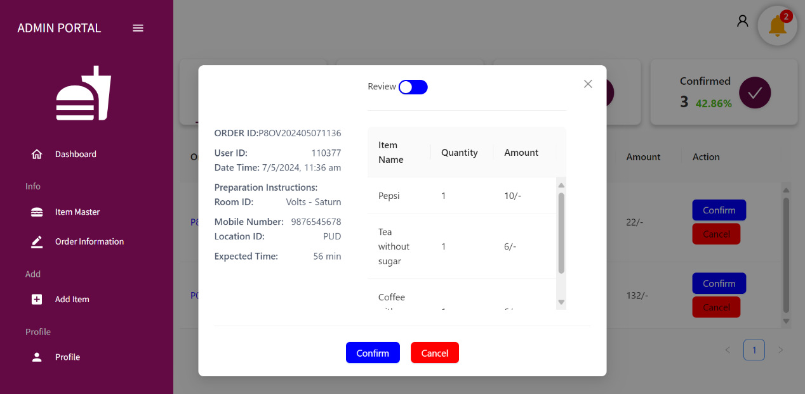

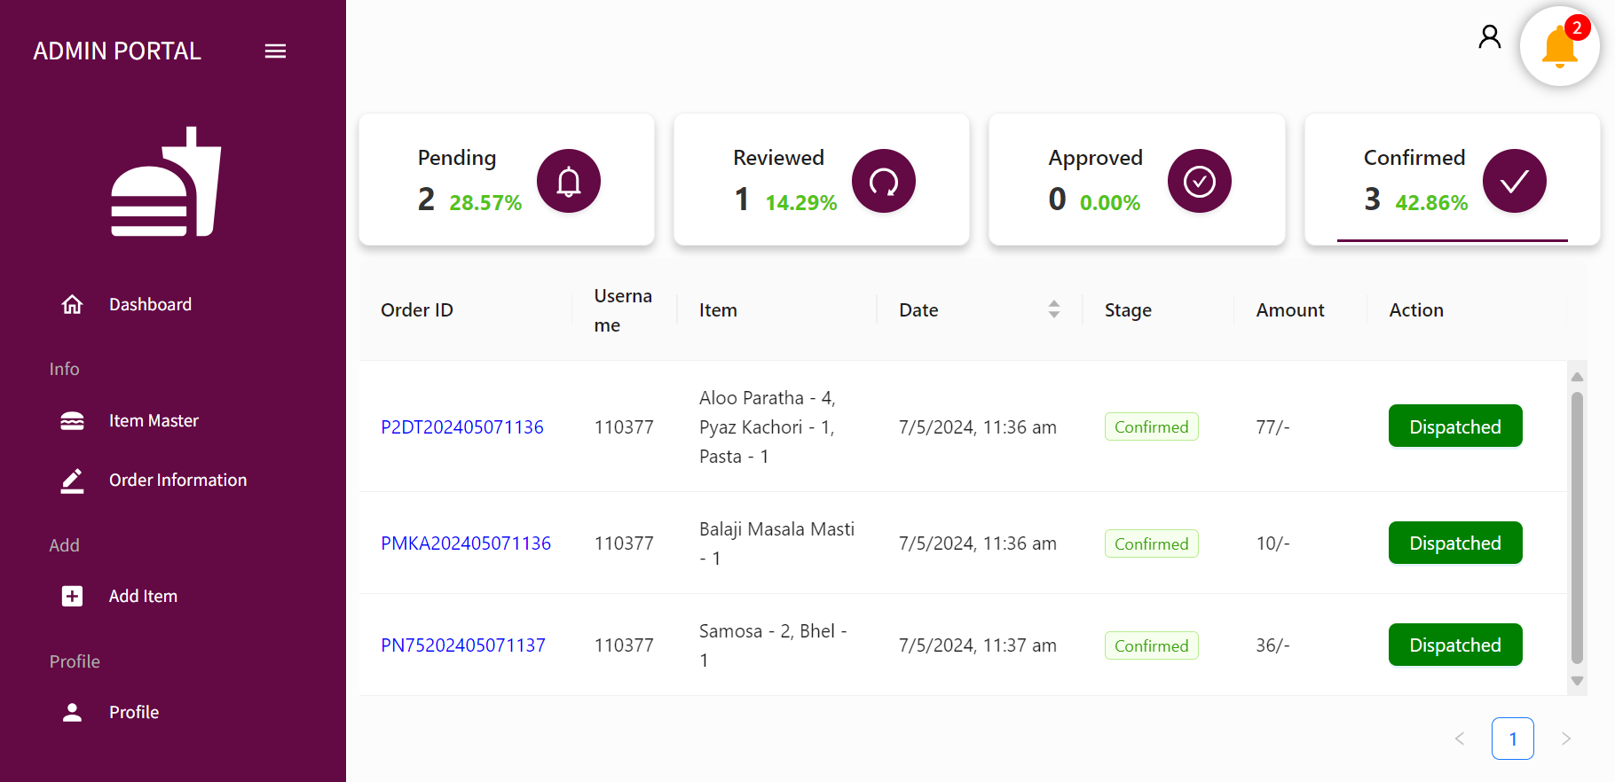

**Order Information Page:**

The order information page on the admin panel provides a comprehensive view of each order, detailing key information to facilitate efficient management. This includes:

1. **Order Number:** Unique identification number assigned to each order for easy reference and tracking.
2. **Username:** The name or username of the user who placed the order, allowing administrators to identify the customer associated with each transaction.
3. **Items:** A detailed list of items included in the order, specifying the quantity of each item selected by the user.
4. **Current Stage:** This indicates the current status or stage of the order within the processing workflow. It may include stages such as pending, approved, reviewed, or confirmed, providing administrators with insights into the order's progression.
5. **Amount:** The total amount or cost of the order, including any applicable taxes, fees, or discounts.

By presenting this information in a structured and organized manner, the order information page enables administrators to effectively monitor and manage orders. They can quickly access relevant details, track order statuses, and take appropriate actions to ensure timely fulfillment and customer satisfaction. This streamlined approach enhances operational efficiency and supports seamless order processing within the admin panel.

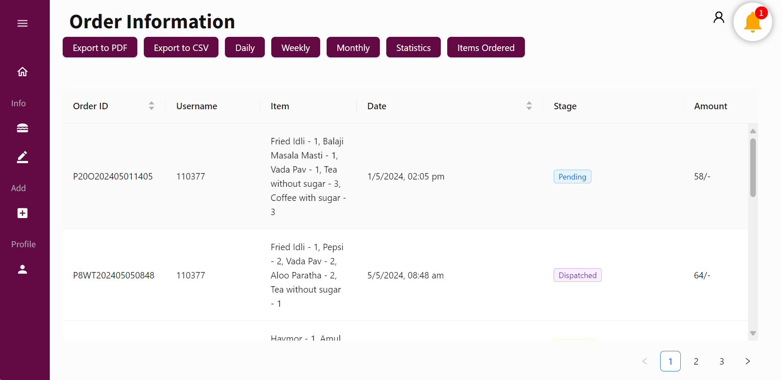

Fig.8 Order Information Page

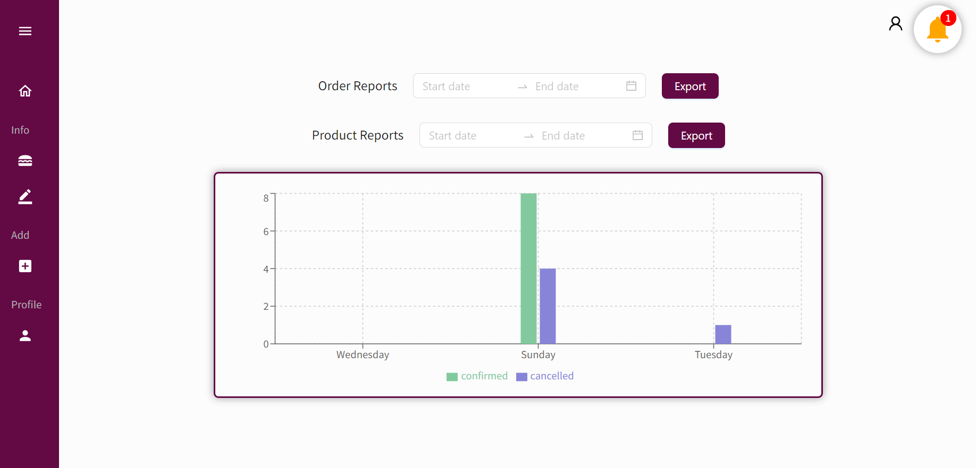

Fig.9 Order Reports Page

**Item Master page:**

The item master page serves as a central hub for managing the inventory of items available for order within the system. Administrators can utilize this page to control the status of each item, toggling between active and inactive as needed.

1. Item Listing: The page displays a comprehensive list of all items available for order, including details such as item name, description, price, and current status (active or inactive).
2. Status Toggle: Administrators have the option to set the status of each item as active or inactive directly from the item master page. This toggle functionality allows for quick and convenient management of item availability.
3. Activation: By setting an item as active, it becomes available for users to select and add to their orders. Active items are visible and can be ordered through the platform.
4. Inactivation: Conversely, setting an item as inactive removes it from the list of available options for users to order. This can be useful for temporarily removing items from the menu, managing inventory levels, or making adjustments to pricing or descriptions.

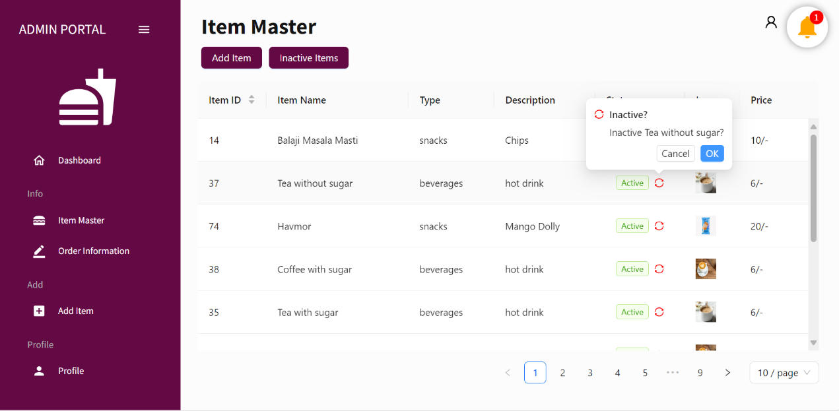

Fig.10 Item Master Page

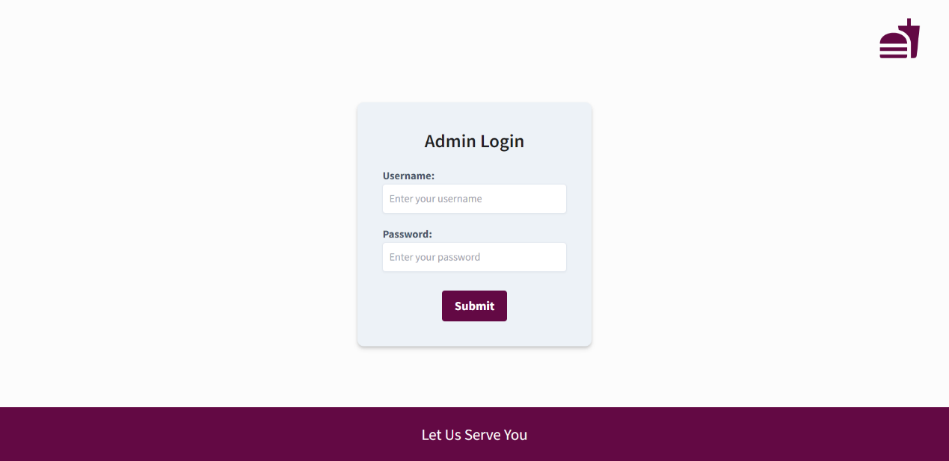

Fig.11 Admin Login Page

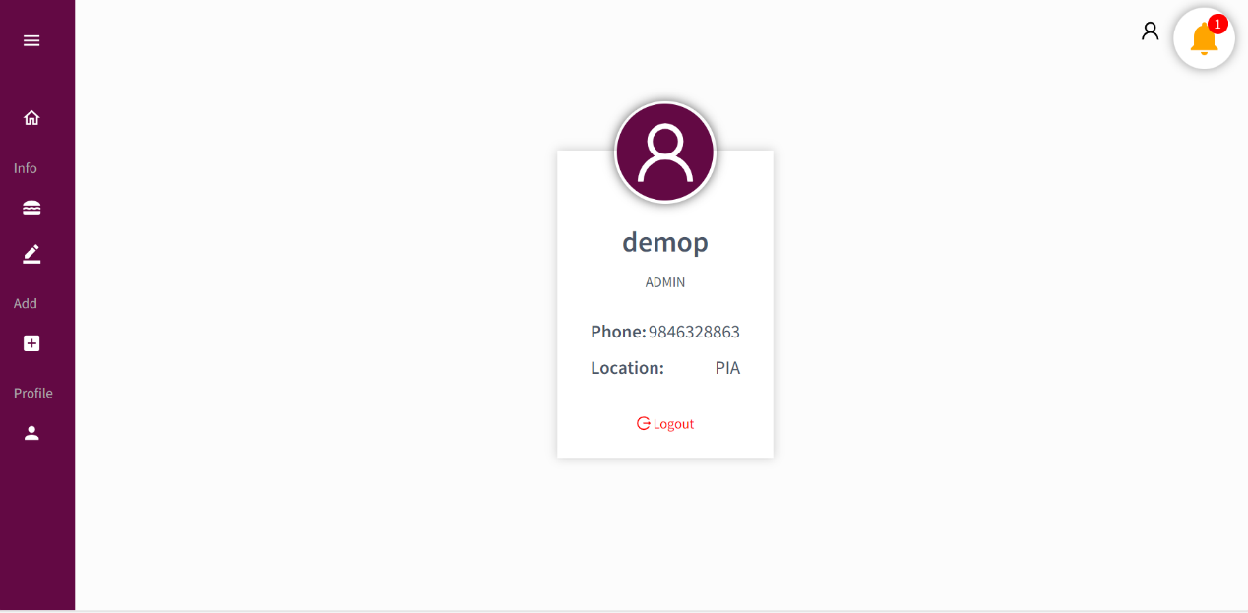

Fig.12 Admin Profile Page

**Conclusion:**

In conclusion, MunchMate emerges as a transformative force in the online food ordering domain, addressing the inherent challenges and inefficiencies prevalent in existing platforms. Through meticulous design and development, MunchMate delivers an unparalleled user experience characterized by its intuitive interface, tailored recommendations, and refined search functionalities. By harnessing the power of real-time order tracking and a comprehensive admin panel, MunchMate not only simplifies the ordering process for customers but also empowers restaurant partners with efficient order management tools. As MunchMate ventures forward, it aspires to reshape the digital dining landscape, setting new standards of convenience, reliability, and satisfaction. With a commitment to innovation and user-centricity, MunchMate is poised to revolutionize how individuals engage with food online, fostering a culture of culinary exploration and delight.

**Future Scope:**

**Mobile Application:** Develop a dedicated mobile app for MunchMate to cater to users who prefer ordering food on-the-go. The app can offer additional features such as location-based recommendations, push notifications for order updates, and in-app messaging for customer support.

**Integration with Social Media Platforms:** Explore integration with popular social media platforms to allow users to share their dining experiences, reviews, and recommendations with their social networks. This can help increase brand visibility and user engagement.

**Multi-Language Support:** Implement multi-language support to make MunchMate accessible to a broader audience, especially in regions with diverse linguistic backgrounds. This can enhance user inclusivity and expand the platform's reach.

**Analytics and Business Intelligence:** Integrate analytics and business intelligence tools to gather insights from user behavior, order patterns, and restaurant performance. This data can be used to optimize recommendations, improve operational efficiency, and tailor marketing strategies.

**Customer Loyalty Program:** Implement a customer loyalty program to reward frequent users with discounts, exclusive offers, or loyalty points redeemable for future orders. This can incentivize repeat business and foster customer retention.

**Expansion to New Markets:** Explore opportunities to expand MunchMate to new geographic markets, partnering with local restaurants and adapting the platform to meet the specific needs and preferences of each region.

**Integration with Third-Party Services**: Partner with third-party services such as food delivery logistics providers, payment gateways, or restaurant management systems to enhance the platform's functionality and offer additional value to users and restaurant partners.

**Enhanced Admin Tools:** Continuously improve the admin panel with new features and tools to streamline order management, automate routine tasks, and provide actionable insights for restaurant partners to optimize their operations.

**User Feedback Mechanisms:** Implement robust feedback mechanisms to gather user feedback and suggestions for further improving the platform. Regularly review and prioritize user feedback to drive iterative enhancements and ensure customer satisfaction.

**Sustainability Initiatives:** Introduce sustainability initiatives such as eco-friendly packaging options, support for locally sourced ingredients, or partnerships with environmentally conscious restaurants to align MunchMate with evolving consumer preferences and global sustainability goals.

By pursuing these future scope initiatives, MunchMate can continue to innovate and evolve, staying ahead of market trends and meeting the evolving needs of its users and stakeholders.

**BIBLIOGRAPHY:**

1. VS Code : <https://code.visualstudio.com/docs>
2. React JS : <https://react.dev/learn>
3. Node JS : <https://nodejs.org/docs/latest/api/>
4. PostgreSQL : <https://www.postgresql/docs/>